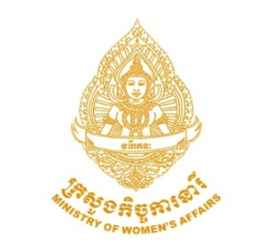
Announcement Description
Ministry of Women's Affairs (MoWA): the ‘Leading the Way for Gender Equality’ (LWGE) program is a 4-year program (2017-2020) whose overall objective is “Enabled environment for gender equality, women’s empowerment and feminist leaderships in Cambodia through enhanced capacities of the gender machineries.” The LWGE program is supported by the Swedish International Development Agency (Sida) and the United Nations Development Programme (UNDP), and Oxfam Cambodia.
The program aims to strengthen government and multi-stakeholder coordination mechanisms for gender equality and women’s empowerment, and strengthen bilateral cooperation between MoWA and selected ministries, public institutions, universities, youth groups, CSOs and media.
The program is seeking qualified, talented, and result-oriented candidates to fill the 2 positions below:
Announcement Positions
- National Gender Mainstreaming Specialist
- National Gender Program Specialist

Workplace: MoWA (Phnom Penh)
Schedule: Full-time
Contract Type: 1 Year Contract (to be extended)

Application Information
Detailed TOR of 2 posts can be seen at www.mowa.gov.kh or requested at below email.
To apply, please send by email your cover letter and CV -including names of at least 3 referees- to the contact below. Qualified candidates who are females, have a disability, are LGBTI, indigenous and/or Khmer Islam are encouraged to apply.
All job applications are kept confidential. Only shortlisted candidates will be contacted for interview.
Closing date: 5th July 2018
Contact Details:
Phone: 077 697 272 (Ms. Ay Sophea)
Email: info.lwge@mowa.gov.kh

